Openfire setup – cheapest hosting package $5 /month [proof of concept]

# Openfire service started on Linux Host

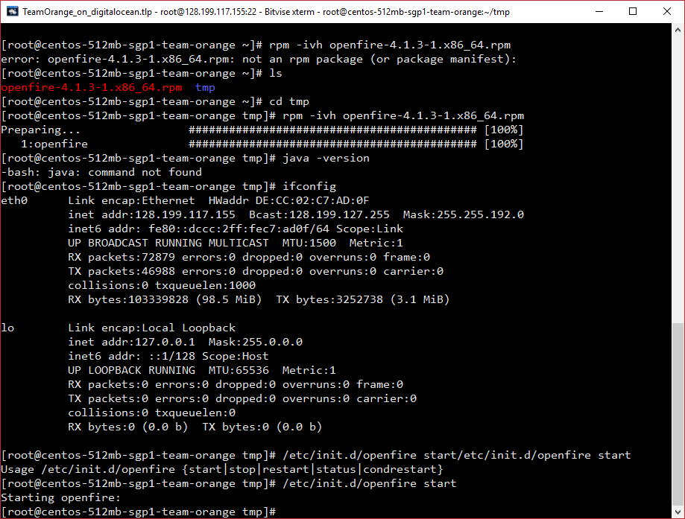

# Navigate to machine ip port 9090

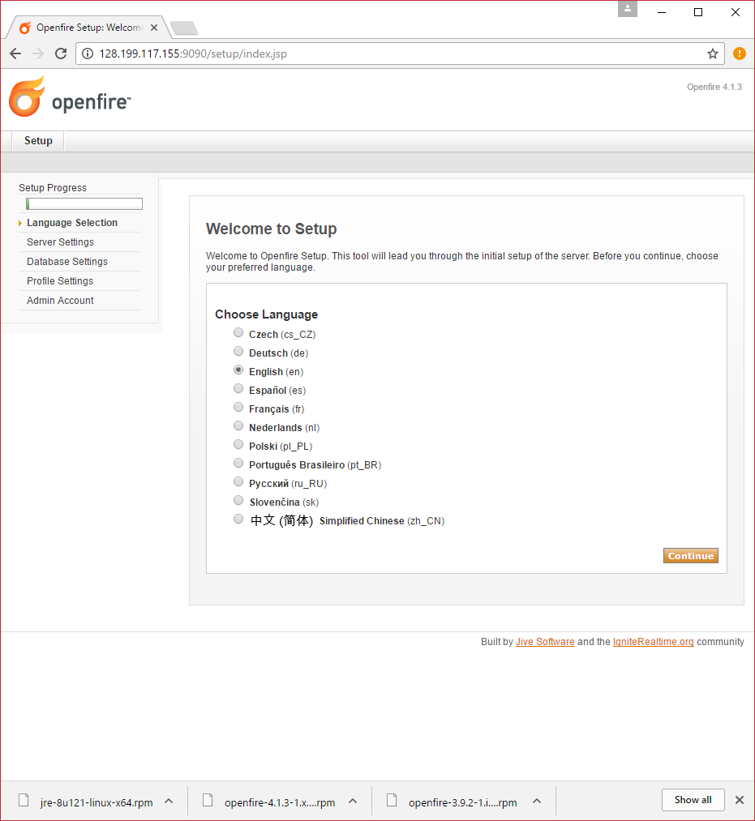

# Add Domain Details

FQDN is if you use a subdomain eg chat.teamorange.space

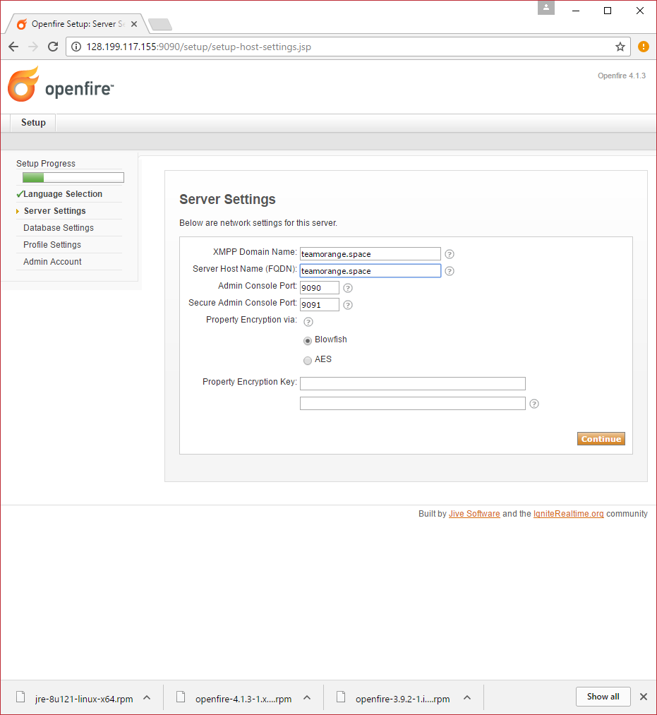

# Embedded database option

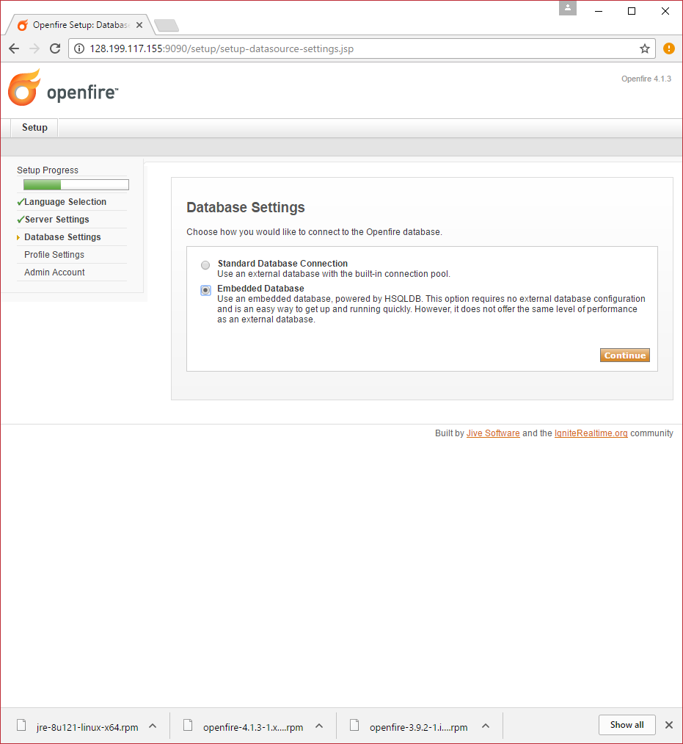

# Basic Accounts Only (no ldap)

Each user will be an admin so they can go in and create their own details.

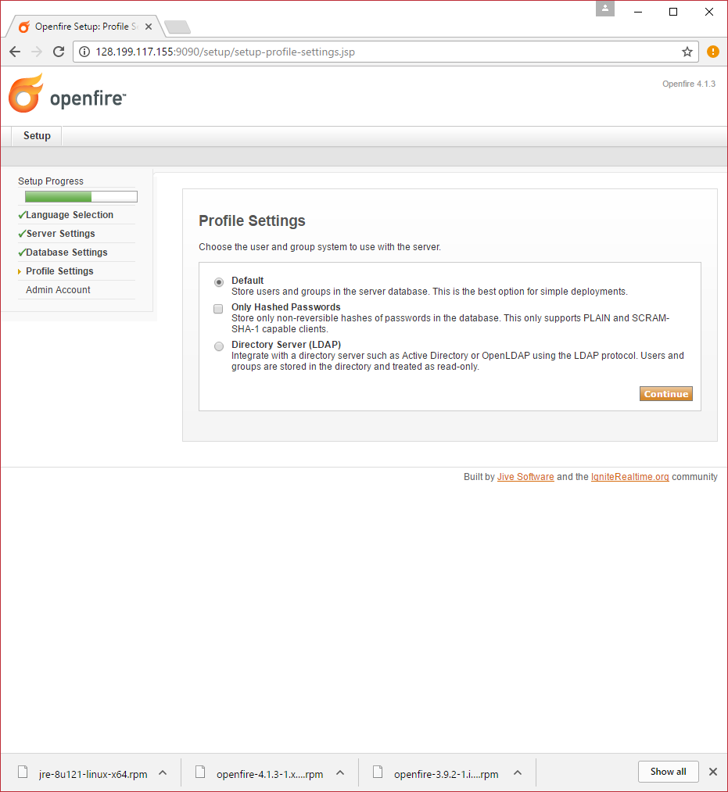

# Create admin account

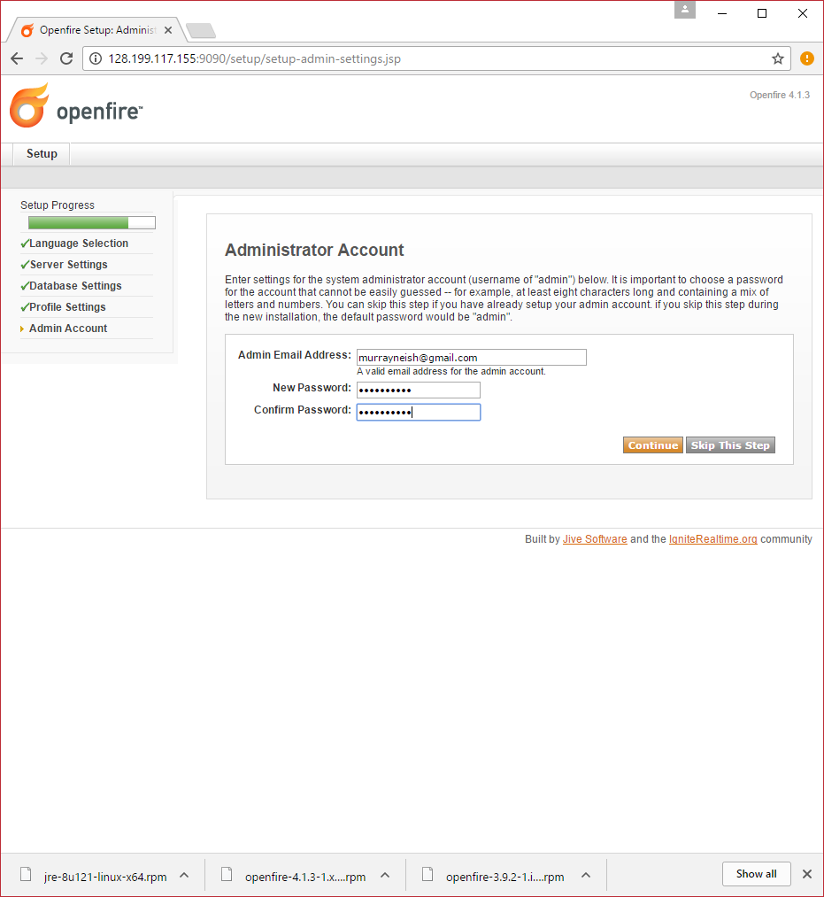

# Setup Complete!

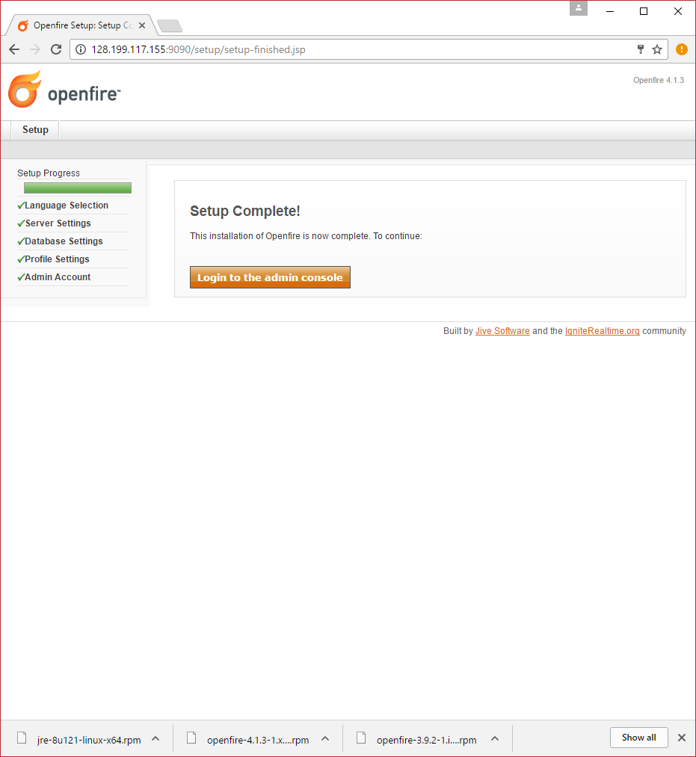

# Admin Console login

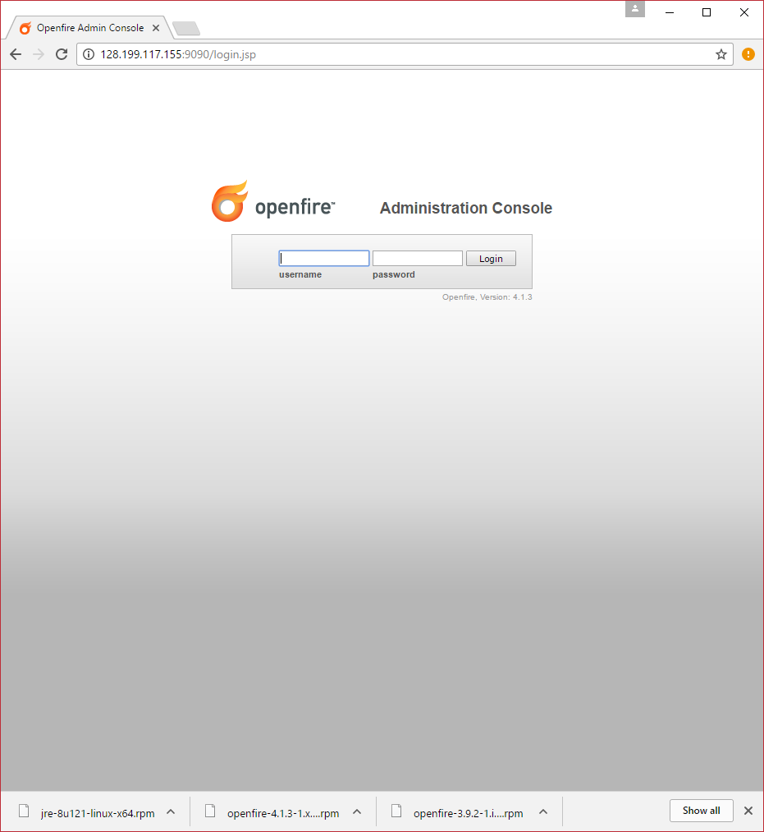

# OpenFire Homepage

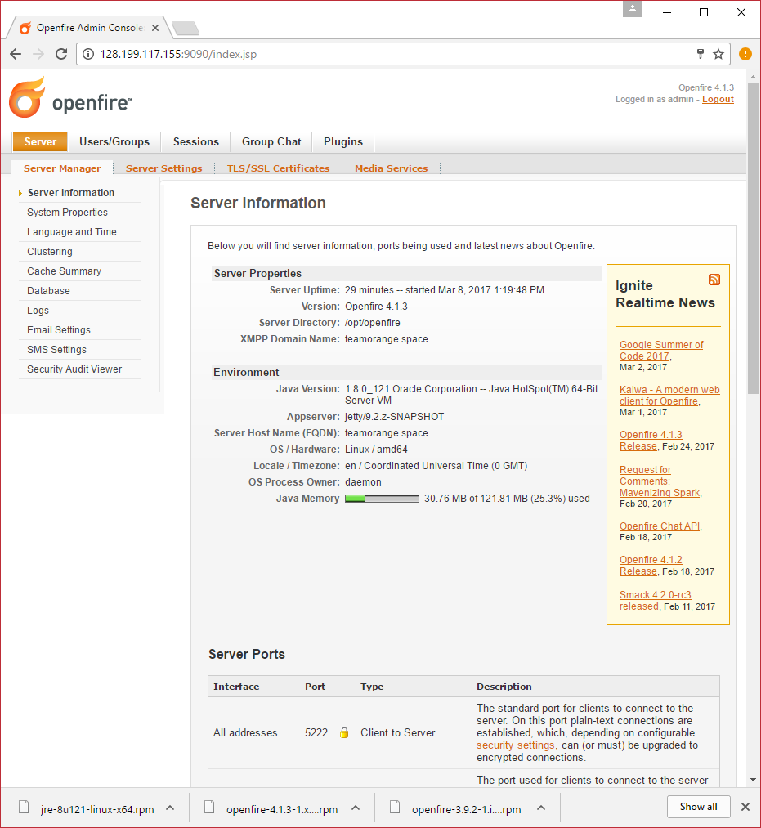

# Alternate login using teamorange.space domain:

